Round Up
City of Clovis, Transit Division
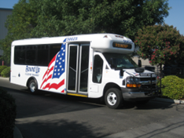
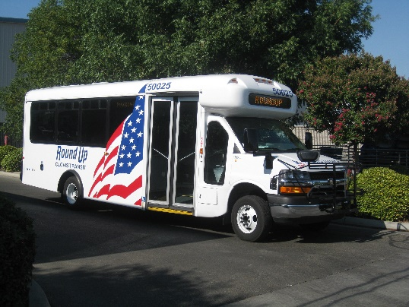
Clovis Transit System Map

A paratransit transportation
program serving the
City of Clovis for ADA
qualified individuals who
are unable to access
fixed route services.

For more information, call:
559-324-2760
California Relay: 711
Round Up is not a medical transport,
an emergency service, or a taxi service.

Round Up All-Electric Bus

What is Round Up?
Round Up is a paratransit bus service for disabled Clovis residents who cannot use fixed route (Stageline) due to geographical and/or other limitations. It is a shared-ride service. We pick up and drop off as close to the door of your destination as possible. Additional assistance is available upon request.

Qualifying for Round Up
A potential passenger is required to complete the Round Up Americans with Disabilities Act (ADA) application. Eligibility will be determined using standards set by ADA law. You will be notified of your eligibility status by mail within 21 days after your completed application is received by our office.

If you have been ADA-certified by another transit system, you will be allowed to the use Round Up service for 21 days while the Round Up certification paperwork is processed.

Hours and Areas of Service
Phone Hours
Monday-Friday 7:00am-7:00pm
Saturday/Sunday 7:30am-3:30pm
To cancel an early appointment, you can leave a message on our after-hours answering system.

Service Hours
Clovis: Monday-Friday 6:00am-7:00pm
Saturday & Sunday 7:30am-3:30pm
Fresno: Monday-Friday 6:00am-5:00pm

Saturday service includes all of Clovis and locations within 3/4 miles of our fixed route service, which includes a limited area of Fresno. Sunday service is for Clovis-only trips.

For trips outside of the Fresno service area or between Fresno addresses, passengers can coordinate with Fresno Handy Ride. See the map on the reverse side for the service area boundaries.
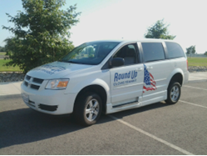
Round Up Wheelchair Van

Making an Appointment
Ride requests can be made up to 14 days in advance. Same-day appointments are available as time allows. Passengers must have their date, time, and destination address ready. When the appointment is taken, the caller will be given an estimated arrival time (within a 30 minute window).

For a return ride, passengers can call Round Up when they are ready to go to their next destination. The dispatcher will give the passenger an approximate arrival time.

Fares
Passengers ride free of charge on Clovis Transit vehicles.

Additional Information

Clovis Transit operates paratransit buses and vans to provide service to our disabled residents. Vehicles are scheduled and dispatched according to availability. We cannot accommodate special requests.

Passengers who plan to bring a personal care attendant, family member, or friend with them should inform the appointment desk when making an appointment. This is especially important if guests are under 18 years old.

Cancellations must be made at least an hour prior to the be-ready time. Repeated late cancels and no-shows could result in service suspension.

The ride is considered on time if the driver arrives within the 30-minute pickup window. The driver waits 5 minutes. Once they leave, they cannot return.

For the safety of the driver, they are limited to lifting up to a total of five bags, up to 25 lbs. Many riders use a wire shopping cart for easier transportation.

Trained service animals are welcome on all Clovis Transit vehicles. Pets must ride in a secure, leak-proof carrier.

Download the Mobile App and Book Your Ride Directly:

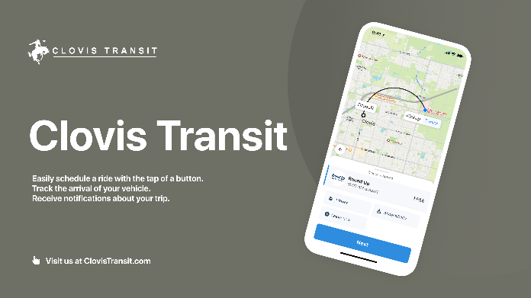
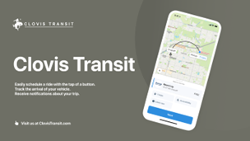

Phone: 559-324-2760
Fax: 559-324-2853

The map shows the principal service area for Round Up. Boundaries are subject to change.
For specific information on service area boundaries, please call 559-324-2760.

Round Up
City of Clovis, Transit Division
Clovis Transit System Map

A paratransit transportation
program serving the
City of Clovis for ADA
qualified individuals who
are unable to access
fixed route services.

For more information, call:
559-324-2760
California Relay: 711
Round Up is not a medical transport,
an emergency service, or a taxi service.

Round Up All-Electric Bus

What is Round Up?
Round Up is a paratransit bus service for disabled Clovis residents who cannot use fixed route (Stageline) due to geographical and/or other limitations. It is a shared-ride service. We pick up and drop off as close to the door of your destination as possible. Additional assistance is available upon request.

Qualifying for Round Up
A potential passenger is required to complete the Round Up Americans with Disabilities Act (ADA) application. Eligibility will be determined using standards set by ADA law. You will be notified of your eligibility status by mail within 21 days after your completed application is received by our office.

If you have been ADA-certified by another transit system, you will be allowed to the use Round Up service for 21 days while the Round Up certification paperwork is processed.

Hours and Areas of Service
Phone Hours
Monday-Friday 7:00am-7:00pm
Saturday/Sunday 7:30am-3:30pm
To cancel an early appointment, you can leave a message on our after-hours answering system.

Service Hours
Clovis: Monday-Friday 6:00am-7:00pm
Saturday & Sunday 7:30am-3:30pm
Fresno: Monday-Friday 6:00am-5:00pm

Saturday service includes all of Clovis and locations within 3/4 miles of our fixed route service, which includes a limited area of Fresno. Sunday service is for Clovis-only trips.

For trips outside of the Fresno service area or between Fresno addresses, passengers can coordinate with Fresno Handy Ride. See the map on the reverse side for the service area boundaries.
Round Up Wheelchair Van

Making an Appointment
Ride requests can be made up to 14 days in advance. Same-day appointments are available as time allows. Passengers must have their date, time, and destination address ready. When the appointment is taken, the caller will be given an estimated arrival time (within a 30 minute window).

For a return ride, passengers can call Round Up when they are ready to go to their next destination. The dispatcher will give the passenger an approximate arrival time.

Fares
Passengers ride free of charge on Clovis Transit vehicles.

Additional Information

Clovis Transit operates paratransit buses and vans to provide service to our disabled residents. Vehicles are scheduled and dispatched according to availability. We cannot accommodate special requests.

Passengers who plan to bring a personal care attendant, family member, or friend with them should inform the appointment desk when making an appointment. This is especially important if guests are under 18 years old.

Cancellations must be made at least an hour prior to the be-ready time. Repeated late cancels and no-shows could result in service suspension.

The ride is considered on time if the driver arrives within the 30-minute pickup window. The driver waits 5 minutes. Once they leave, they cannot return.

For the safety of the driver, they are limited to lifting up to a total of five bags, up to 25 lbs. Many riders use a wire shopping cart for easier transportation.

Trained service animals are welcome on all Clovis Transit vehicles. Pets must ride in a secure, leak-proof carrier.

Download the Mobile App and Book Your Ride Directly:

Phone: 559-324-2760
Fax: 559-324-2853

The map shows the principal service area for Round Up. Boundaries are subject to change.
For specific information on service area boundaries, please call 559-324-2760.

